Coursework 2 Results by Tukpetov Raiymbet

The prior probability of node 0
0.651 0.188 0.038 0.010 0.006 0.002 0.004 0.001 0.102

The mean vector:
1.164 3.916 0.448 5.679 4.865 3.778 4.127 3.604 0.217

The covariance:
5.880 0.245 -0.004 -0.284 -0.346 -0.417 -0.481 -0.267 -0.067
0.245 7.572 0.073 -0.358 -0.346 0.257 2.273 0.946 -0.032
-0.004 0.073 0.247 -0.116 -0.039 -0.003 0.100 0.066 -0.005
-0.284 -0.358 -0.116 16.960 7.969 4.443 -1.036 -0.306 0.047
-0.346 -0.346 -0.039 7.969 8.361 4.921 -0.763 -0.752 -0.001
-0.417 0.257 -0.003 4.443 4.921 6.683 -0.087 -0.376 -0.141
-0.481 2.273 0.100 -1.036 -0.763 -0.087 20.583 1.122 0.014
-0.267 0.946 0.066 -0.306 -0.752 -0.376 1.122 4.317 0.119
-0.067 -0.032 -0.005 0.047 -0.001 -0.141 0.014 0.119 0.170

The magnitudes of c.pgm:
1206.254 -1590.133 -248.136 -821.249 246.009 -771.900 963.633 376.967 161.599 -533.276

Eigenface images:
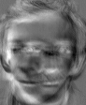

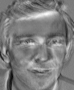
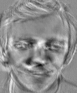
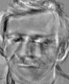
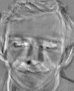


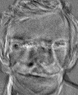
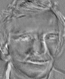

Partial reconstructions of c.pgm:
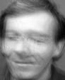










New Eigenface Images:
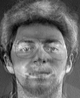
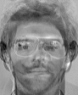
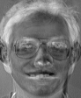

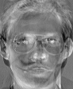
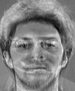


New Partial Reconstruction:






